Project Design Phase-II
Data Flow Diagram & User Stories

Date | 08\03\2026
Team ID | SWTID-2026-4737
Project Name | Product inventory management -np
Maximum Marks | 4 Marks

Data Flow Diagrams:
A Data Flow Diagram (DFD) is a graphical tool used to illustrate how information moves within a system. It provides a clear and organized view of the system’s processes and requirements. The diagram explains how data is received by the system, how it is processed, and how it is transferred to different parts of the system. It also shows where the data is stored and how it leaves the system after processing. 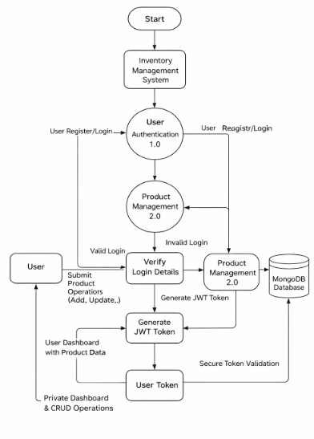
User Stories
Use the below template to list all the user stories for the product.
User Type | User Story Number | User Story / Task | Acceptance Criteria | Priority | Release
Customer (Web User) | USN-1 | As a user, I can register and log in securely using JWT authentication | User can create account and receive token after login | High | Sprint-1
Customer (Web User) | USN-2 | As a user, I can add new products to my inventory | Product is saved and visible only to logged-in user | High | Sprint-1
Customer (Web User) | USN-3 | As a user, I can view all my products in a dashboard | Products load successfully with valid token | High | Sprint-1
Customer (Web User) | USN-4 | As a user, I can update product details like price and quantity | Changes are saved and reflected instantly | Medium | Sprint-2
Customer (Web User) | USN-5 | As a user, I can delete products from my inventory | Product disappears from dashboard after deletion | Medium | Sprint-2
Customer (Web User) | USN-6 | As a user, I can search products by name | Filtered results appear based on keyword | Low | Sprint-2

